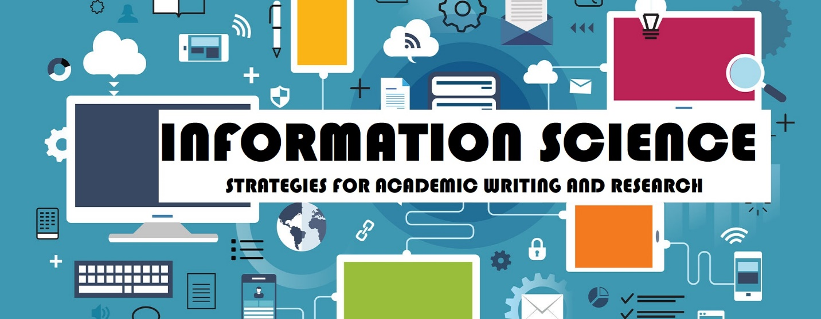

Academic writing and research are integral components of information science studies. Here are some strategies and tips for information science students to excel in these areas:

**Academic Writing Strategies:**

*1. Understand the Assignment:* Before you start writing, thoroughly understand the assignment or research question. If anything is unclear, seek clarification from your instructor.

*2. Plan Your Writing:* Create an outline or structure for your paper or report. Organize your thoughts and main points logically, including an introduction, body paragraphs, and a conclusion.

*3. Thesis Statement:* Develop a clear and concise thesis statement that outlines the main argument or purpose of your paper. Your thesis should guide the entire document.

*4. Cite Sources Properly:* Information science often requires referencing scholarly sources. Use a citation style (e.g., APA, MLA, Chicago) appropriate for your field and follow it consistently.

*5. Avoid Plagiarism:* Always attribute ideas and information that are not your own. Plagiarism is a serious academic offense. Learn how to paraphrase and quote properly.

*6. Revise and Edit:* Writing is a process. After completing a draft, take time to revise and edit your work. Check for clarity, coherence, grammar, and spelling errors.

*7. Seek Feedback:* Share your drafts with peers or professors for feedback. Constructive criticism can help you improve your writing.

*8. Use Academic Language*: Write in a formal and scholarly tone. Avoid colloquial language and slang. Use subject-specific terminology accurately.

*9. Conciseness:* Be concise and get to the point. Avoid unnecessary words or overly complex sentences. Clarity is key.

*10. Proofread Carefully:* Carefully proofread your final draft to catch any remaining errors. Consider reading your work aloud to identify awkward phrasing or unclear sentences.

**Research Strategies:**

*1. Define Your Research Question:* Clearly define your research question or objective. This will guide your entire research process.

*2. Use Quality Sources:* Rely on reputable sources such as peer-reviewed journal articles, books, and academic databases. Be critical of sources found on the internet, and verify their credibility.

*3. Library Resources:* Utilize your university's library resources, including research databases and librarians who can assist with finding relevant sources.

*4. Keyword Search:* Use appropriate keywords and Boolean operators (AND, OR, NOT) when conducting literature searches. This will help you find relevant articles and books efficiently.

*5. Take Effective Notes:* When reading sources, take clear and organized notes. Include bibliographic information for easy citation later.

*6. Manage Citations:* Use reference management software like Zotero, EndNote, or Mendeley to organize and format your citations and bibliography.

*7. Keep a Research Journal:* Maintain a research journal to track your progress, ideas, and any challenges you encounter during your research.

*8. Evaluate Sources*: Critically evaluate the sources you find for relevance, reliability, and credibility. Consider the source's authorship, publication date, and methodology.

*9. Synthesize Information:* Synthesize information from multiple sources to develop a comprehensive understanding of your research topic.

*10. Ethical Research*: Adhere to ethical guidelines in your research, including obtaining necessary permissions for data collection and respecting the privacy and confidentiality of research subjects.

*11. Stay Organized:* Keep your research materials, notes, and sources well-organized. This will save you time and prevent information from getting lost.

*12. Time Management:* Set aside dedicated time for research and writing. Break your work into manageable tasks and create a timeline to meet deadlines.

Remember that academic writing and research skills develop over time with practice. Seek guidance from professors and mentors, and be open to learning from your experiences as an information science student.